Preparation of manuscript for Archives of Electrical Engineering

(Received: DD.MM.YEAR, revised: DD.MM.YEAR)

Abstract: This instruction provides guidance on the preparation of manuscripts for the Archives of Electrical Engineering (AEE) journal. Use this document as a template and an instruction set for your article. The electronic file containing your manuscript will be further formatted by the Technical Editor of AEE. Manuscript titles should include uppercase and lowercase characters. Avoid writing long formulas with subscripts in the title; short formulas that identify the elements are fine (e.g., "Nd–Fe–B"). Define all symbols used in the abstract. Do not cite references in the abstract. The abstract should be complete in itself and not exceed 250 words.
Key words: a list of 3-6 key words placed in an alphabetical order and separated by commas has to be added immediately after the abstract

- Introduction

This instruction contains guidelines for preparing manuscripts for the AEE journal – Open Access publication. The document serves as a template for Microsoft Word. If you use the LaTex format, please transfer your document to Microsoft Word and then use this Template.
Before you begin to format your paper, write and save the content as a separate text file. Keep your text and graphic files separate until after the text has been formatted and styled. Do not use hard tabs, and limit use of hard returns to only one return at the end of a paragraph. Do not add any kind of pagination anywhere in the paper. Do not number text heads-the template will do that for you.
AEE is published in Open Access, which means that all articles are available on the internet to all users immediately upon publication free of charge for the readers. Authors are invited so a declaration that they are ready to cover the costs of printing their article.
The AEE journal publishes an ORCID for all authors. You will need a registered ORCID in order to submit your paper for peer review. ORCID registration is free and only takes a minute. Please note that ORCIDs will be added in the course of the author's proofreads.
While editing your paper, make sure that all the mathematical characters (symbols, identifiers, variables, vectors, axis marks, etc.) have the required shape, thickness, and slant kept throughout the whole article. The same appearance of a given mathematic character must be retained regardless of its place (text, equations, tables or figures).
The articles that don’t conform to the above will not be processed and published.

- Guidelines for AEE manuscript preparation

The manuscript submitted for publication should have no less than 12 pages .In the case of the manuscript longer than 20 pages, please contact the AEE Editorial Board before submitting your paper. The manuscript should be written on an A4 sheet in Times New Roman, 10pt font size, single line spacing, and 3.8 cm margins.
The manuscripts, written in UK English, should be typed using a standard word processor according to the following instructions and should include: a title page with the title of a manuscript, a short title; abstract; key words, text; list of references. A DOI number as well as received and revised data will be completed by Editor. When you open Template.doc, select “Print Layout” from the “View” menu in the menu bar (View > Print Layout). Then type over sections of Template.doc or cut and paste from another document and then use markup styles (Home > Styles). For example, the style at this point in the document is “main text”).
All papers submitted for publication are assessed on the basis of the mutual anonymity rule as to the names of reviewers and authors. Authors’ names and affiliations should not appear in the attached text/tables/figures.
If English is not your first language, ask an English-speaking colleague to proofread your manuscript. The manuscripts that fail to meet basic standards of literacy are likely to be immediately declined or after the language assessment, sent to the authors for linguistic improvement
The manuscripts are published on average within 3 months after their acceptance.
Do not change the font sizes or line spacing to squeeze more text into a limited number of pages. Leave some open space around your figures.

- Math

Please use the MathML editor as well as MathType editor to build an equation in your manuscript..

- Equations
Equations should be typed within the text, centered, and should be numbered consecutively throughout the text. Their numbers should be typed in parentheses, flush right. Equations should be referred to in text, e.g. (1), except at the beginning of a sentence: “Equation (1) is ...”. All symbols appearing in equations have to be defined in the text, before or just after the equation. Please keep the same font in the formulas and text.
If the symbols are written in Times New Roman use italic fonts. Symbols of vectors and matrices should be written in bold fonts. Do not italicize Capital Greek fonts and mathematical symbols like e.g.: the derivative symbol d, max, min, etc. The indices of symbols that are indices themselves should be written in a clear manner.
Use a long dash (“ ̶ ”) rather than a hyphen for a minus sign.
, (1)
where: E_{m} is co-energy, i is the current vector, α is the angle describing the rotor position, R_{n} is the resistance, (NOT R_{n} - resistance), u_{n} is the total voltage of the n-th winding, etc. Note that the equation is centered using a center tab stop.
, (2)
where: is the unit permeance and is the function of the MMF of winding “a”.

- Unit symbols, abbreviations

Define abbreviations and acronyms the first time they are used in the text, even after they have been defined in the abstract. Abbreviations such as IEEE, SI, MKS, CGS, sc, dc, and rms do not have to be defined. Do not use abbreviations in the title or heads unless they are unavoidable.
Si units are recommended for use in formulas, drawings and tables., for example the SI unit for magnetic field strength H is A/m. Apply the center dot to separate compound units, e.g., “N·m.
Do not mix complete spellings and abbreviations of units: “Wb/m²” or “webers per square meter,” not “webers/m².” Spell units when they appear in text: “...a few henries…”, not “...a few H…”.
Use a zero before decimal points: “0.25,” not “.25.” Use “cm³,” not “cc.”
Unit symbols, SI prefixes as well as abbreviations should be writing in accordance with the IEEE standard – http://www.ewh.ieee.org/soc/ias/pub-dept/abbreviation.pdf

- Guidelines for graphics preparation
and submission

The illustrations (line diagrams and photographs) should be suitable for direct reproduction. The lettering as well the details should have proportional dimensions to maintain their legibility after the usual reduction.
All illustrations should be numbered consecutively (Fig. X). Tables are numbered with Arabic numerals.
All figures, figure captions, and tables in the text must be inserted into the correct places.
Figures, photos, tables or other parts of a manuscript that have previously appeared in another publication or are not the property of the authors must be properly acknowledged in the manuscript. Permission to republish these items must be obtained by the corresponding author from a person or institution holding the copyright, usually the publisher.
Authors are requested to send all drawings used in the article in additional files. Create a separate file for each image. Images should be submitted in a bitmap format (.jpeg) or/and in a vector format (.pdf). Each file must be saved according to the number in the original article, e.g.: FIG1.JPG or FIG1.PDF. Bitmap illustrations must be “flattened”, which means no additional layers, for example, covering old descriptions.
Photographs, colour, and greyscale figures should be at least at a resolution of 400 dpi.
All colour figures should be generated in the RGB or CMYK colour space, while greyscale images in the greyscale colour space.
Tables are numbered with Arabic numerals. Use 9 point Times New Roman for the title of the table and 9 point Times New Roman for the filling of the table (9 in the case of symbols with subscripts).
When preparing your figures/graphics etc., we suggest the use of the Arial 8 point font for axis numbers and Arial 9 point font for axis names. Figures/graphics etc. can be prepared in one of two proposed ways.

(a) | 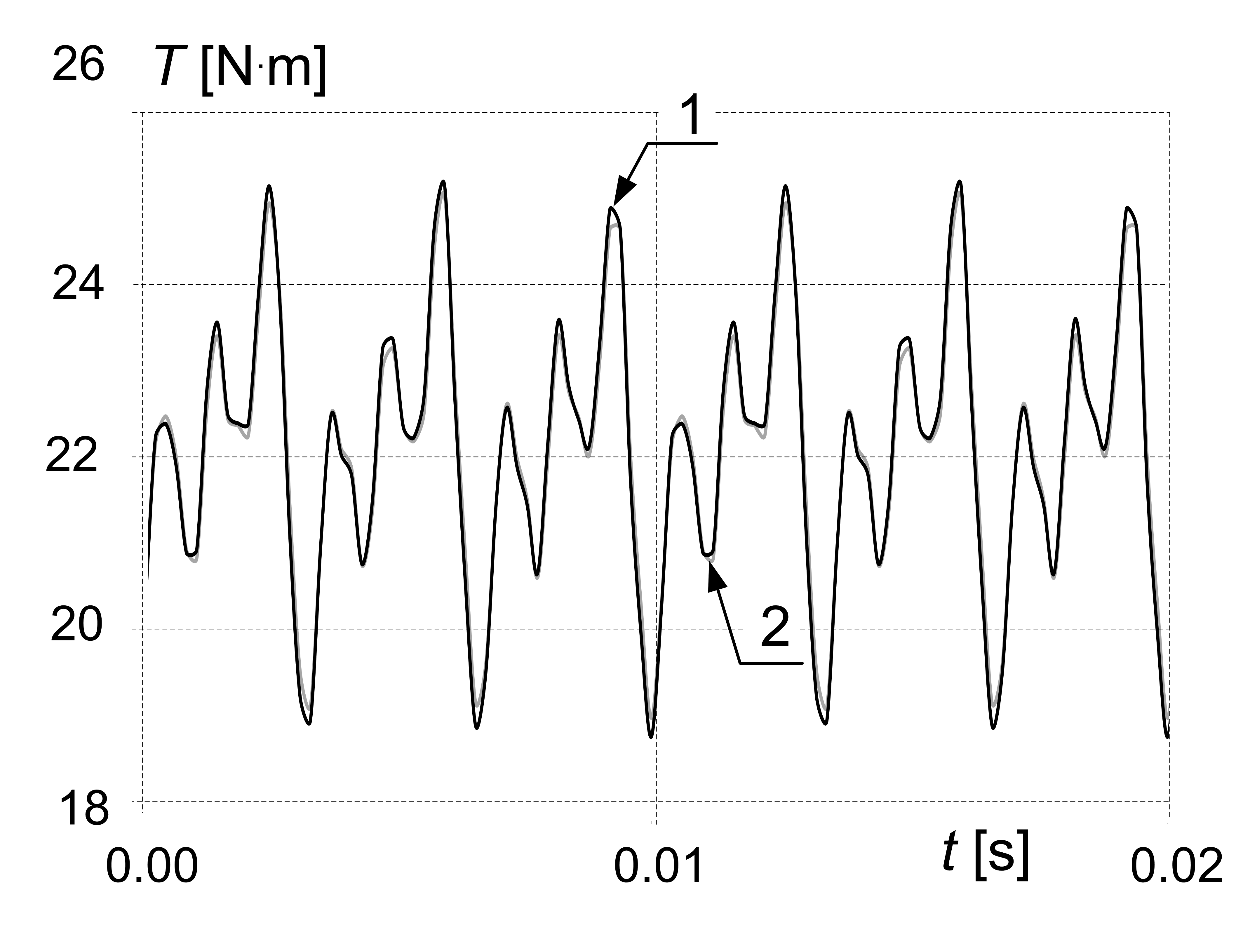  (b)
- Results of current and torque calculation for methods 1 and 2: current i versus time (a); torque T versus time (b)

- Rotor speed as a function of time
for motors 1 and 2

Tables are numbered with Arabic numerals. Use 9 point Times New Roman for the title of the table and 9 point Times New Roman for the filling of the table (9 in the case of symbols with subscripts).

- Title of the table
Parameter name | Symbol | Value | Unit
Inductance 1 | L₁ | 1.125 | mH
Resistance 1 | R₁ | 100 | mΩ
Inductance 2 | L₂ | 1.125 | mH
Resistance 2 | R₂ | 100 | mΩ

- Conclusions

A conclusion might elaborate on the importance of the work or suggest applications and extensions. Although a conclusion may review the main points of the manuscript, do not replicate the abstract as the conclusion.

Appendix
Appendixes, if needed, appear before the acknowledgment.

Acknowledgements
Use the singular heading even if you have many acknowledgments.

References
References in text must be numbered consecutively by Arabic numerals placed in square brackets. Please make sure that you use full names of journals i.e. Archives of Electrical Engineering. Please ensure that all references in the Reference list are cited in the text and vice versa.
Editors of the AEE intend to strengthen the position of the Archives of Electrical Engineering. Therefore, we would appreciate it if you will rely on the papers published in our journal. As a result, it will increase the rank of the journal, and thus raised by your papers.
Please provide name(s) and initials of author(s), the title of the manuscript, editors (if any), the title of the journal or book, a volume number, the page range, and finally the year of publication in brackets.
You can use the rules presented on the site:
https://ieeeauthorcenter.ieee.org/wp-content/uploads/IEEE-Reference-Guide.pdf

Examples of the ways in which references should be cited are given below.

Journal manuscript

- Author1 A., Author2 A., Title of paper, Title of periodical, vol. x, no. x, pp. xxx­xxx (YEAR), DOI:10.24425/aee.2021.ABCDEF.
example
- Steentjes S., von Pfingsten G., Hombitzer M., Hameyer K., Iron-loss model with consideration of minor loops applied to FE-simulations of electrical machines, Archives of Electrical Engineering. vol. 49, no. 7, pp. 3945–3948 (2019), DOI:10.24425/aee.2021.ABCDEF.
- Idziak P., Computer Investigation of Diagnostic Signals in Dynamic Torque of Damaged Induction Motor, Electrical Review (in Polish), to be published.
- Cardwell W., Finite element analysis of transient electromagnetic-thermal phenomena in a squirrel cage motor, submitted for publication in IEEE Transactions on Magnetics.

Conference manuscript

- Author A., Title of conference paper, Unabbreviated Name of Conf., City of Conf., Country of Conf., pp. xxx­xxx (YEAR).
example
- Popescu M., Staton D.A., Thermal aspects in power traction motors with permanent magnets, Proceedings of XXIII Symposium Electromagnetic Phenomena in Nonlinear Circuits, Pilsen, Czech Republic, pp. 35–36 (2016).

Book, book chapter and manual

- Author1 A., Author2 A.B., Title of book, Name of the publisher (YEAR).
example
- Zienkiewicz O., Taylor R.L., Finite Element method, McGraw-Hill Book Company (2000).

Patent

- Author1 A., Author2 A., Title of patent, European Patent, EP xxx xxx (YEAR).
example
- Piech Z., Szelag W., Elevator brake with magneto-rheological fluid, European Patent, EP 2 197 774 B1 (2011).

Thesis

- Author A., Title of thesis, PhD Thesis, Department, University, City of Univ. (YEAR).
example
- Driesen J., Coupled electromagnetic-thermal problems in electrical energy transducers, PhD Thesis, Faculty of Applied Science, K.U. Leuven, Leuven (2000).

Electronic forms

- Author A., Title of article, in [Title of Conference, record as it appears on the copyright page], © [applicable copyright holder of the Conference Record] (copyright year), doi: [DOI number].
example
- Kubo M., Yamamoto Y., Kondo T., Rajashekara K., Zhu B., Zero-sequence current suppression for open-end winding induction motor drive with resonant controller, in IEEE Applied Power Electronics Conference and Exposition (APEC), © APEC (2016), doi: 10.1109/APEC.2016.7468259

Website
- http://www.aee.put.poznan.pl, accessed April 2010.

LICENSE TO PUBLISH FORM

The authors are requested to submit a completed LICENSE TO PUBLISH (AEE LICENSE TO PUBLISH.pdf). A Creative Commons Attribution-NonCommercial-NoDerivatives 4.0 International (CC BY-NC-ND 4.0) license is offered. Assignment of LICENSE is available at http://aee.put.poznan.pl/ (Instructions for Authors).
The e-version of the License to publish should be sent to the Editorial Office via e-mail immediately after the final version of the accepted manuscript was submitted for publication in the AEE journal.

FEES FOR PUBLISHING THE PAPERS

AEE is published in Open Access, which means that all articles are available on the internet to all users immediately upon publication free of charge for the readers. Authors will be asked to a declaration that they are ready to cover the costs of printing their article. The publication cost in the AEE journal is estimated at €300 (Euros). From 2024, the Archives of Electrical Engineering will be published exclusively in electronic form.

PUBLICATION PRINCIPLES

- Submission of a manuscript to the Archives of Electrical Engineering journal is understood to imply that the manuscript is original, unpublished and is not being considered for publication elsewhere.
- All manuscripts will be reviewed.
- Each manuscript submitted for publication in Archives of Electrical Engineering is subjected to the following review procedure:
a) the manuscript is reviewed by the editor in chief or guest editor for general suitability for publication in AEE,
b) if it is judged suitable two reviewers are selected and a double blind peer review process takes place,
c) based on the recommendations of the reviewers, the editor then decides whether the manuscript should be accepted in its present form, revised or rejected,
d) the author(s) is(are) informed by e-mail on the results of the reviewing procedure.
- The manuscript is published in electronic and hard-copy versions.
- From 2024, the Archives of Electrical Engineering will be published exclusively in electronic form.
- All manuscripts should be submitted electronically on www.editorialsystem.com/aee

